Healey says Mass. won’t cooperate with mass deportations

Gov. Maura Healey said that State Police would not be used to deport migrants, and vowed to use "every tool in the toolbox" to counter the next Trump administration.
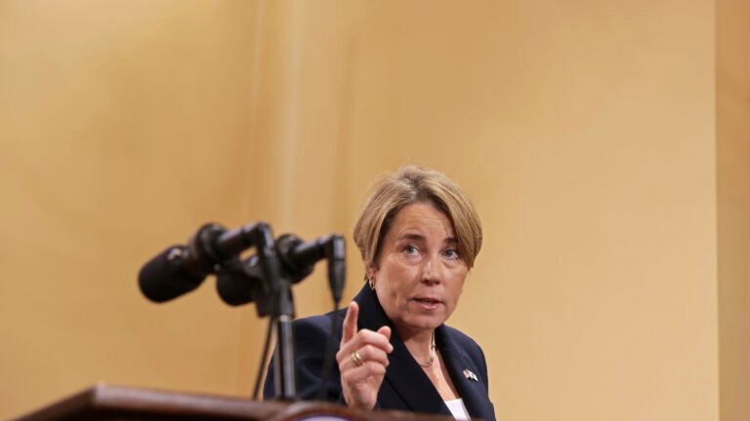
Gov. Maura Healey responds to a final question before leaving a press conference this week. Pat Greenhouse/The Boston Globe
By Ross Cristantiello
November 8, 2024

Massachusetts Gov. Maura Healey said this week that her administration would not cooperate with federal authorities looking to conduct mass deportations of undocumented immigrants once President-elect Donald Trump takes office.
Trump has vowed to oversee the “largest deportation effort in American history,” something that would involve rounding up as many as 13 million people nationwide and cost at least an estimated $315 billion, according to the American Immigration Council. When asked about the cost of a deportation operation on that scale recently, Trump said that “there is no price tag.”
In an interview on MSNBC Wednesday, Healey was asked whether the Massachusetts State Police would cooperate with the Trump administration if it were to request the agency’s help in deportation efforts.
“Absolutely not,” Healey said. The situation “in the courts” is very different in 2024 than it was in 2016, she added. While litigation against the Trump administration is still on the table, Healey said she would support other ways of resistance. This could include using the state’s regulatory authority, her executive powers, and state legislation.
“There’s a lot of other ways that people are going to act, and need to act, for the sake of their states and their residents,” Healey said. “Every tool in the toolbox has got to be used to protect our citizens, to protect our residents, and protect our states, and certainly to hold the line on democracy and the rule of law.”
Trump coasted to victory this week on the back of dehumanizing rhetoric repeatedly aimed at undocumented immigrants, who he says are ruining the “fabric” of the country. The U.S. has never deported more than half a million immigrants per year, let alone 13 million.
An operation on that scale would necessitate the use of detention facilities and temporary camps. To put that in context, American Immigration Council researchers pointed out in a recent report that the entire U.S. prison and jail population in 2022 was 1.9 million people.
Election news:
- 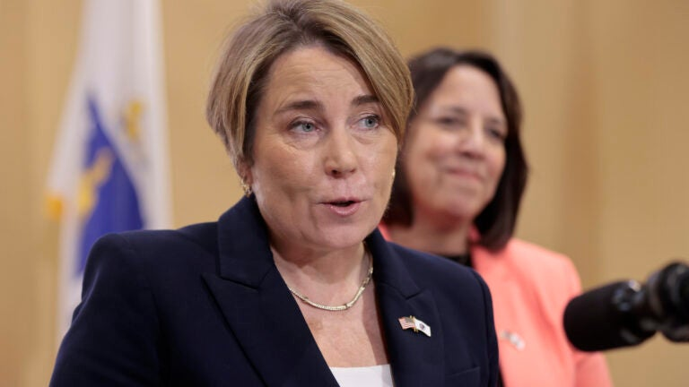

Enforcing federal immigration law “is not a mission of the Massachusetts State Police,” a spokesperson told The Boston Globe this week. A court decision actually prohibits troopers from participating in enforcement operations that rely only on federal immigration detainer requests and not on allegations of actual crimes being committed, the spokesperson added.
As Massachusetts has struggled to shelter a large influx of migrants over the past year, Healey has repeatedly called for lawmakers in Washington to take action.
“I’m not sure what the Trump administration is planning in terms of its actions around immigration, deportations and the like,” she said at an unrelated press conference Friday. “I really hope that the new administration works to secure the border and passes a law with the new Congress that will actually take care of this issue … that has been festering for far too long.”
As the state’s attorney general during Trump’s first term, Healey grew her political profile by repeatedly suing his administration. She ultimately helped file 96 lawsuits, more than all but three other attorneys general. Healey won about 77% of those cases.
But, as Healey said this week, litigation itself might not be sufficient this time around. Democrats across the country are already preparing for the day Trump takes office. Gov. Gavin Newsom of California called state lawmakers into a special session next month to discuss ways to counter the incoming Trump administration on a number of issues.
“You come for my people, you come through me,” Gov. J.B. Pritzker of Illinois declared at a news conference. Bob Ferguson, governor-elect of Washington, said his team was getting ready to defend the basic rights of residents there. Many high-profile Democrats said they have been overseeing contingency plans for a Trump victory since well before election day.
Healey held a press conference on Wednesday, telling reporters that Massachusetts is ready to be governor for all residents regardless of how they voted in the presidential election. She also emphasized that the state is ready to be a national leader.
“This great country of ours is bigger than any one person alone. We all have a role to play in building the kind of community, state, and country that we want to be, and that we want for our children. So it is up to all of us to chart the path forward,” she said. “This is Massachusetts, we’ve been doing that for close to 250 years. People will look to us to lead, and that’s what I, the lieutenant governor, and our entire administration are ready to do.”

Video
https://twitter.com/i/status/1854576417532502287
Massachusetts Gov. Healey addresses Trump losses and voter concerns

Tom Holman on sanctuary State
https://www.msn.com/en-us/news/us/former-ice-director-issues-bold-announcement-on-sanctuary-cities-we-will-hold-them-accountable/vi-AA1tKXui?ocid=socialshare

